Report

Laboratory Work 11

Dmitry Ladutsko

August 20, 2022

# 

# 1. Prerequisites Task Information

## 1.1. Passwords Index

|  |  |  |
| --- | --- | --- |
| Password Group | Login Name | Password |
| Operation System | root | “rootadmin” |
|  | oracle | “oracleadmin” |
|  |  |  |
| Oracle System | sys | “sysadmin” |
|  | system | “sysadmin” |
|  |  |  |
| Oracle Users | All DB users | “%PWD%” |
|  |  |  |
|  |  |  |

## 1.2. Folder Paths Index

|  |  |  |
| --- | --- | --- |
| Path Group | Path Description | Path |
| Operation System | Oracle RDBMS – BIN | /oracle/app/oracle |
|  | Oracle Inventory | /oracle/app/oraInventory |
|  | Oracle Database Storage | /oracle/oradata |
|  | Oracle Install Directory | /oracle/install |
| Oracle | ORACLE_BASE | /oracle/app/oracle |
|  | ORACLE_HOME | $ORACLE_BASE/product/11.2 |
|  |  |  |
| FTP | ftp Incoming Folder | **/ftp/incoming** |
|  |  |  |
|  |  |  |

# 2. ETL Advanced Refresh Scenarios – Refactoring Load to SAL

**Task 01 is common for LabWork 10 (Task 02), 11(Task 01).**

## 2.1. Task 01: Loading to SAL Layer Data

**The Main Task** is to load dimension to SAL layer

**Required points:**

* Create new package for Load FCT_* and DIM_* to SAL Layer
* Load Dimension
* Load SCD Dimension
* Load FCT_*

# 3. Business Task – Performance of STAR Scheme

## 3.1. Task 02: Prepare Report Layout

**The Main Task** is to create Ad Hoc SQL for Report Layout Monthly that was developed on LabWork 2 (Use STAR schema objects for source of Data).

***Note.*** I took **Monthly report group by grouping sets** from Laboratory Work 2, to create a **view as select.** I used **star schema objects** instead of using **transaction table** (as in lab work 2)

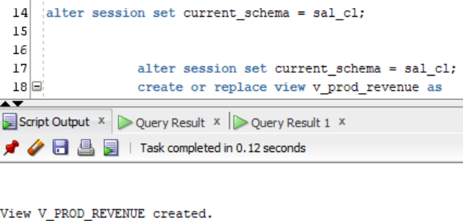

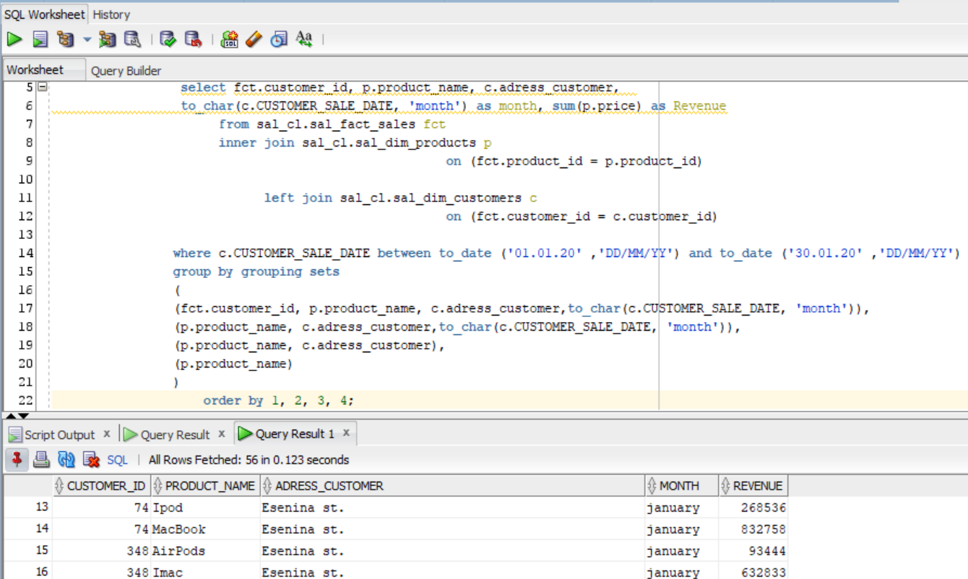

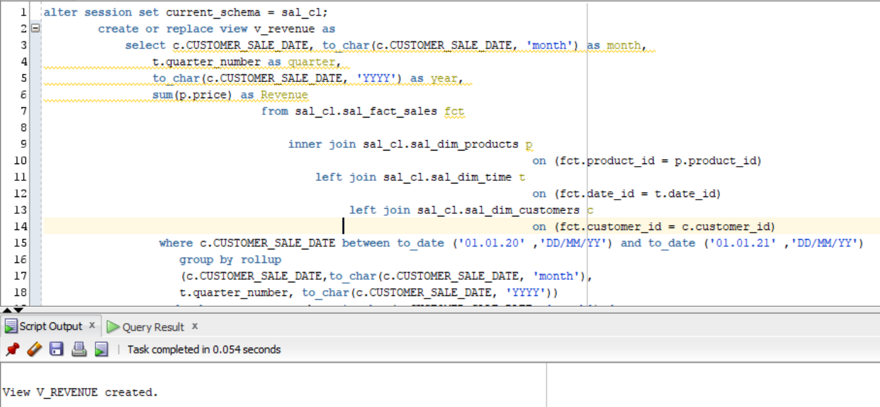

***Note.*** As you can see I have also created a view to see the **summarized revenue** grouped by **day – month – quarter – year** hierarchy using **Star Schema objects**

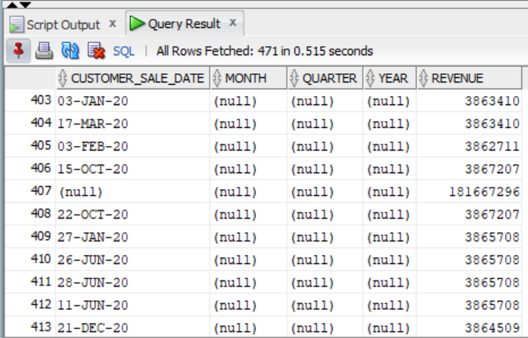

## 3.2. Task 03: Compare Report Layout Performance

**The Main Task** is to create summarize table with comparison Performance of next Report Layout:

* Advancing Grouping (GROUP BY GROUPING SETs – LabWork 02)
* Model Clause (LabWork 05)
* Star Schema (LabWork 11)

**Task Results:**

Create required objects:

* Prepare Document with Summarize table

**Star Schema**

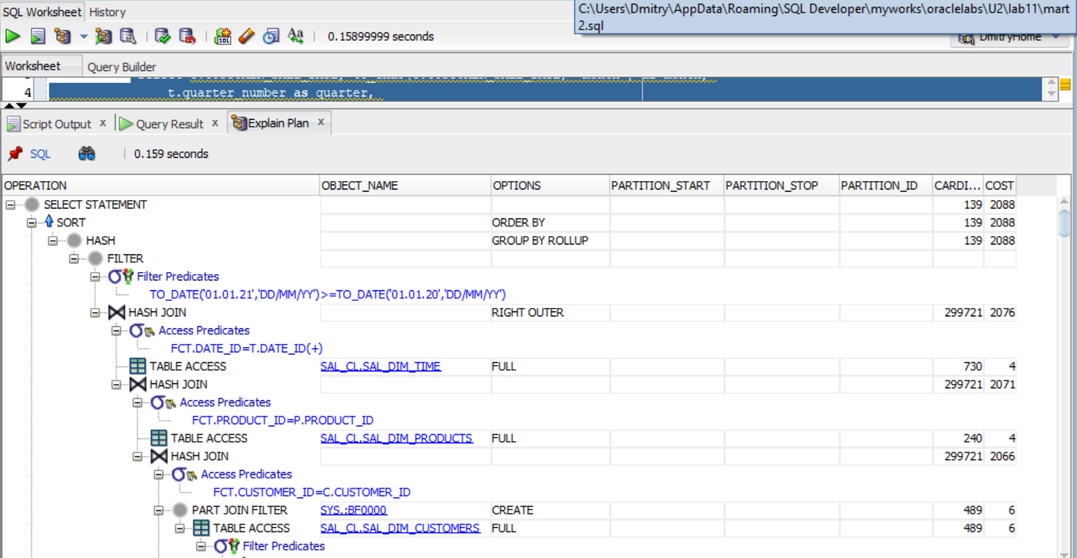

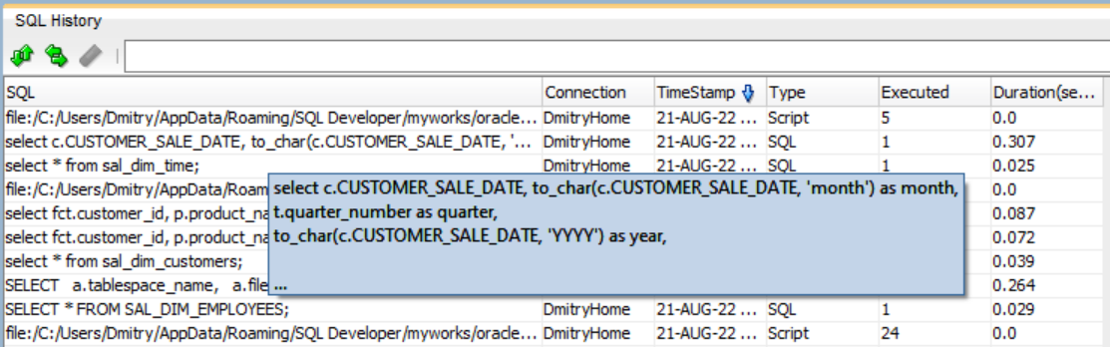

**Model Clause**

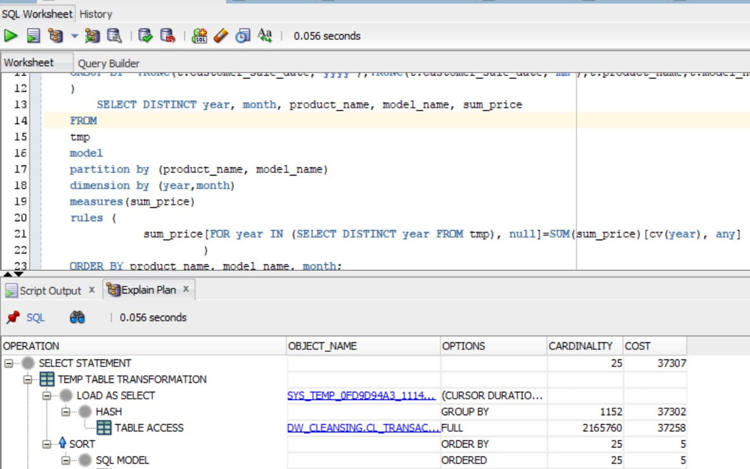

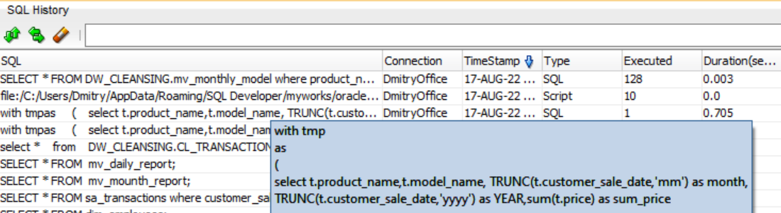

**Advanced Grouping**

|  |  |  |  |
| --- | --- | --- | --- |
| № | Source Type | Explain Plan - Statistics | Time, Sec. |
| 1 | Advancing Grouping (lab 2) | Cost - 10129 | 0.087 |
| 2 | Model Clause (lab 5) | Cost - 37307 | 0.705 |
| 3 | Star Schema (lab 11) | Cost - 2088 | 0.307 |

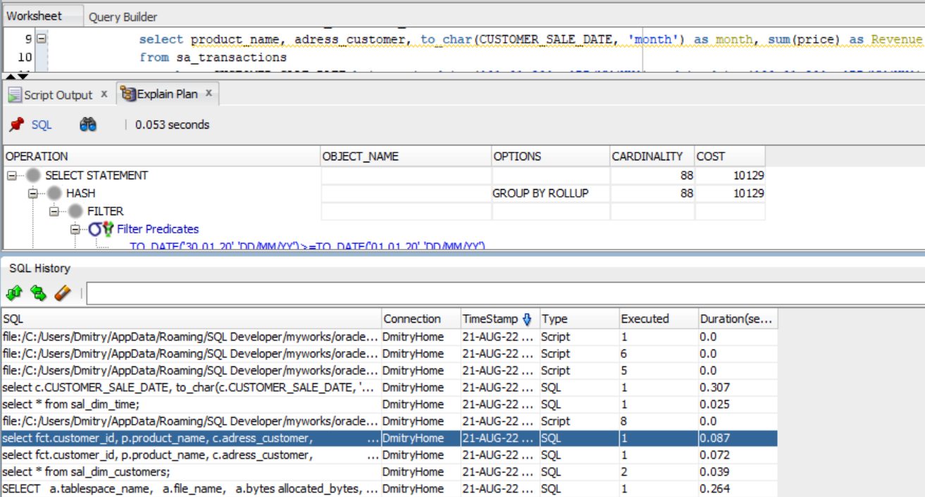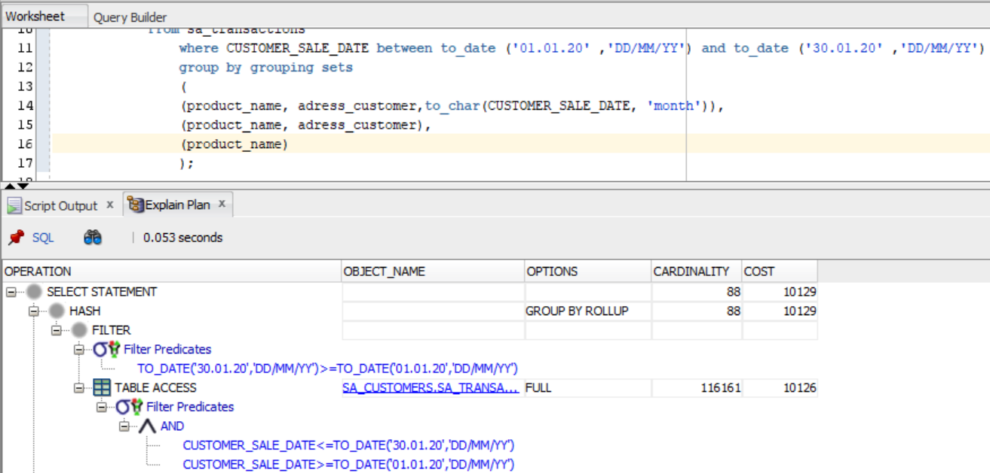

**Laboratory Work Summary**

**At this laboratory work** we created views with different group statements as select from our created star schema. We recalled the explain plan statistic to show how oracle’s optimizer estimates performance of different ways of report outputs.